Standdesign for Opti 2020

Some Data
Name of the fair: Opti
Place: Munich (Germany)
Exhibition Dates: 10-12 January 2020
Size: 35 m2 (7 x 5 m)
Two sides open

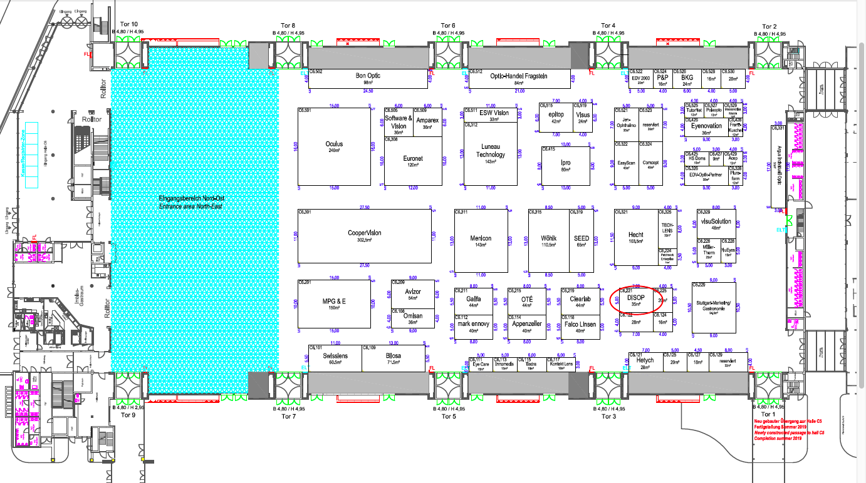

Must be
2 Structures with two big printed canvas to cover each wall. Something like this:
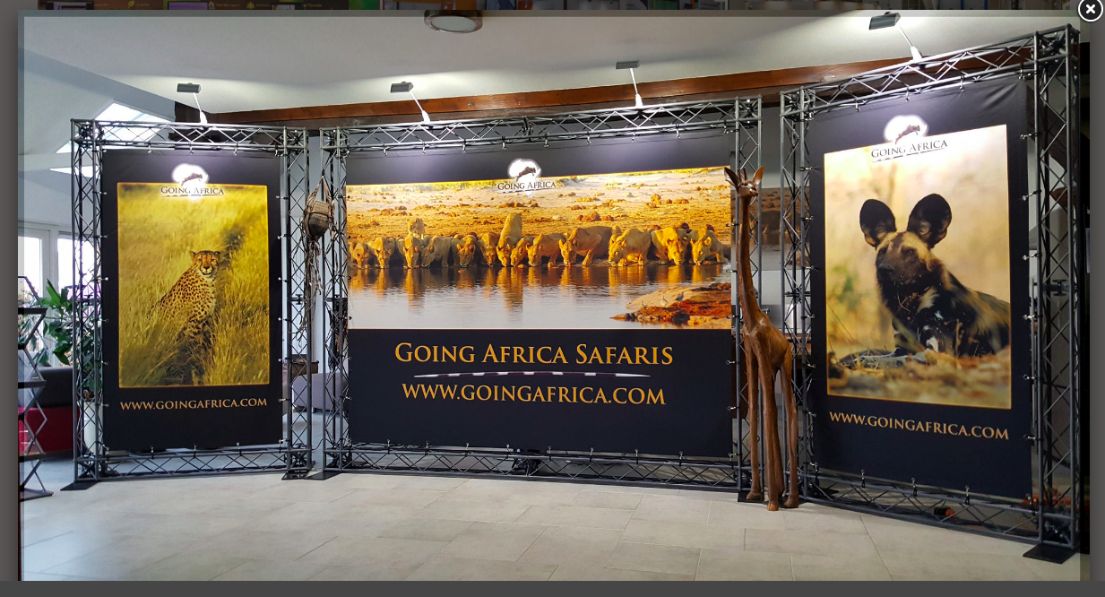
4-5 tables with 4 chairs for each. The model of this furniture should be high quality. For example this one:
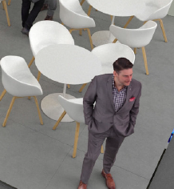
2 display cases to exhibit our products. (Products are multipurpose solutions for cleaning contact lenses)

No room as warehouse. We use a high quality cupboard of wood to storage.
Dimensions of the cupboard to use as storage place:
