Briefing CNC International – Cosmopack Bologna 2024
Thursday 21 – Saturday 23 march 2024

The situation:  Cornerstand in hall 18.  As experienced in previous shows, we noticed that most of the traffic comes from the other hall (please see hall drawing with arrow).  We want to make sure to attract people with our stand in some clever way on that side of the stand.  HALL 18  CORNERSTAND B48  12 x 4 meter = 48 meters | 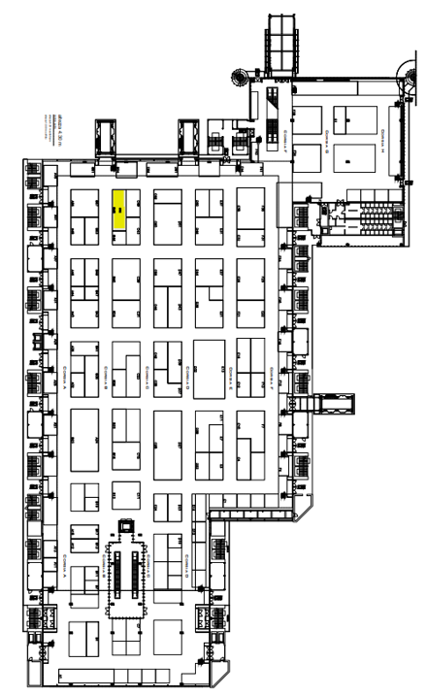

Our stand in Cosmoprof 2023

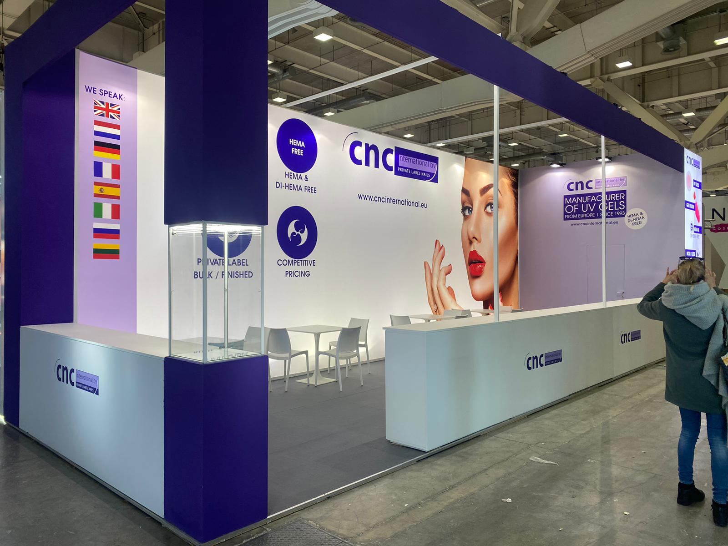
Our ideas for 2024:
- Stand height of 4 meters
- Furniture: 4 tables with 3 chairs / or 1 high table and 3 low tables
- Floor: colored carpet
- Backlit wall(s

- We would like 2 “nail bars” showing our products on a display, it attracts people to test. We show our assortment, latest developments, bestsellers etc. People can test and try. Please see picture below (1)
- We think of a “nail bar” of 4 meters on the short side and 1 nail bar on the long side of approx. 7,5-8 meters long.
- The nail bar height: approx… 1 meter
- Backside of nail bar needs to have shelves and easy to lock/unlock doors
- Current in the nail bar every 1 meter. We want to connect UV lamps here.

- In the corner pillar there needs to be something to attract attention. This pillar is visible while walking in the aisle from the other hall. We want attract people, perhaps with a light box (please find photo (2) of Marc Inbane light box below) We like to hear your ideas for this.
- The cornerpillar could also showcase products, please find photo below. (3)

- We want a pantry of approx.. 1 meter width and with a lockable door. Plus a fridge, coat hooks, a mirror and some shelves inside. We want to connect coffee machine and water kettle cooking device here.

- ”nail bars”with displays to showcase products for testing & trying: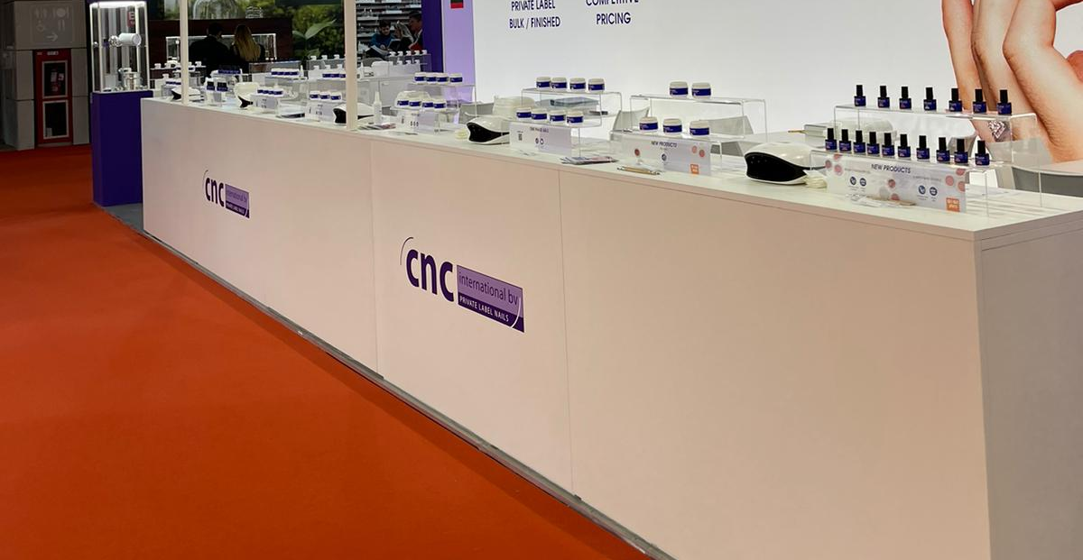

(2) Showcase in corner pillar:
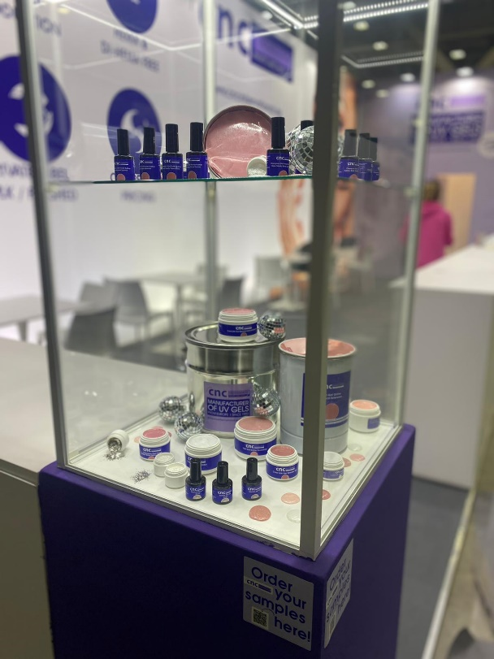

(3) Idea for lightbox with logo connected to the corner pillar:
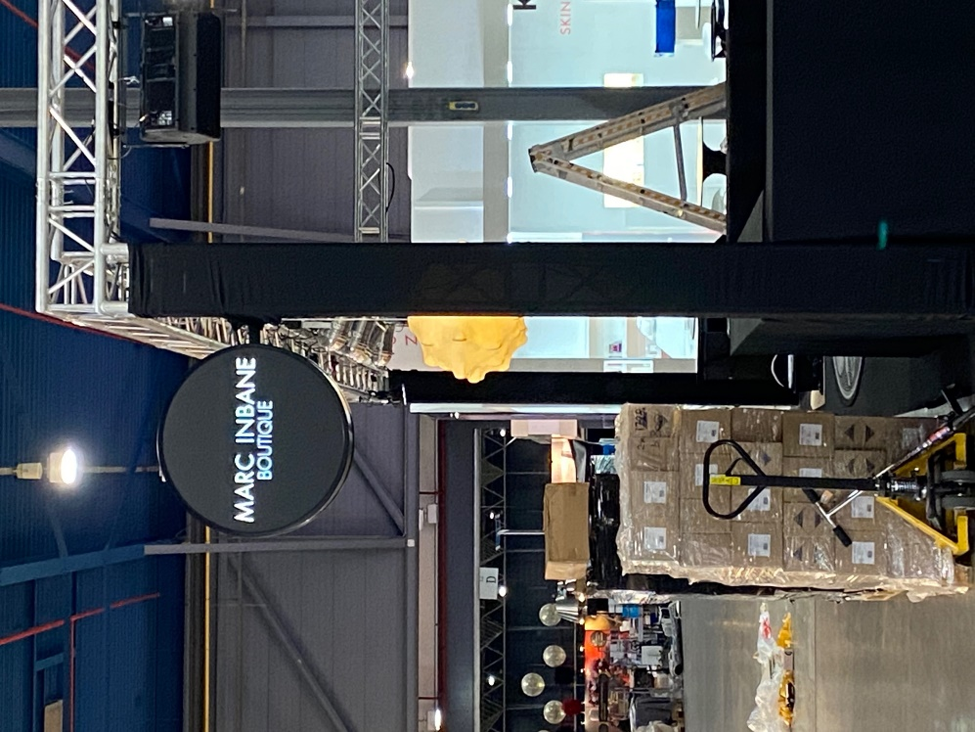

Stand drawing as seen from above

Budget: 8500€

Question:
Please note: for my company it is very important to have the stand delivered in time and delivered clean. In the past we have had stand constructors who delivered the stand very late, messy and dirty so we had problems and stress with getting our stand ready. If we come to an agreement for the stand construction, can we agree for a delivery date and time (March 20th ready at 14.00?)

2023 CNC stand at Cosmopack

<< foto stand invoegen>>

