Briefing Dermatude – Cosmoprof Bologna 2024

In the beauty section we have a shared stand for 2 brands: Dermatude and Nouveau Contour.
Branding is different but the style is possible to match with each other.

The situation  We have a cornerstand. Dermatude brand will be in the free corner, Nouveau Contour in the corner with wall.  HALL 30  STAND E36  4 x 7,5 meter = 30 m2  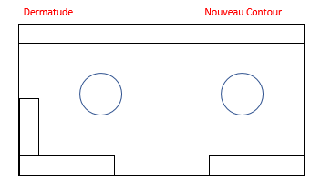 | 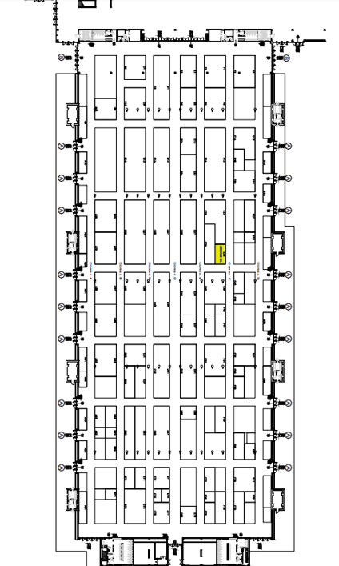

Our ideas:
- Height: 4 meters
- 1 large backlit wall, separated as shown on picture (1)
- Floor: colored carpet

- Lockable closets in the back wall to show products (devices) on top and store goods in side. Closets need to have shelves. Height approx. 1.20m?
- Desks to show products (devices) on (1). In 2023 we had desks with glass top which we liked, but other ideas are welcome. Closets need to have shelves and lockable doors.
- Current in the closet every 1 meter. We want to connect devices, but also a use 1 space underneath the nail bar for coffee machine and water kettle cooking device.

- Tbd in final design… 2 high bar tables with 3 stools + 2 tables of 80cm with 4 small stools?

- Stand design, showing separation in backlit wall + desks with glass top:

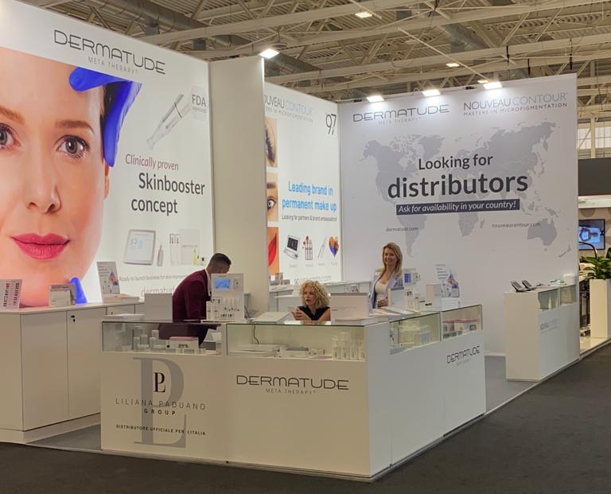

Budget: 7500€

Question:
Please note: for my company it is very important to have the stand delivered in time and delivered clean. In the past we have had stand constructors who delivered the stand very late, messy and dirty so we had problems and stress with getting our stand ready. If we come to an agreement for the stand construction, can we agree for a delivery date and time (March 20th ready at 14.00?)

