
THE SPECIFICATIONS

Identification:
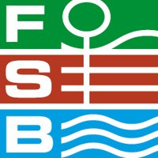
FSB Cologne: from Tuesday 5th to Friday 8th November 2019, 4th edition

INTERNATIONAL TRADE FAIR FOR PUBLIC SPACE, SPORTS AND LEISURE FACILITIES

Fair organizer:
Koelnmesse GmbH
Messeplatz 1
50679 Cologne, Germany
Tel: +49 (0)221 8210
Fax: +49 (0)221 8212574
Organizer mail’s: www.koelnmesse.de
Fair mail’s: www.fsb-cologne.de

Statistics
N° Exhibitiors
N° Visitors
Exhibitors
Visitors
National
Foreign
Foreign
National
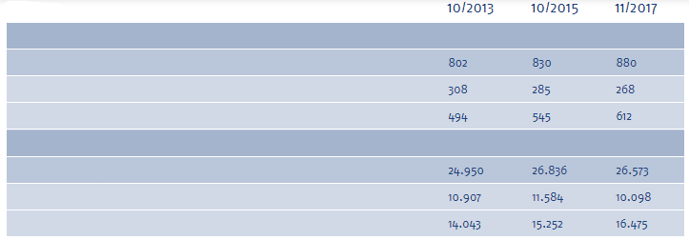

Company presentation:
Proludic designs, manufactures and installs outdoor playground equipment and sports spaces.
We provide area planning project proposals drawing on over 1,200 of our standard catalogue products as well as custom-made projects according to customers’ specific needs.

Direct B to B customers:
- Communities (local councils, council groups, counties, regions ...)
- Education (pre-school, schools, medical-educational institutes ...)
- Tourism and leisure (theme parcs, campsites, sports club, leisure centres ...)
- Business and industry (shopping centers, motorway service areas ...)

Our needs:
The exhibition area
Hall 07.1 D Lane, Stand 058
Located in the playground equipment and sports hall
9 meters x 8 meters - 11 meters high
72 m² - 4 open sides

Marketing and sales objectives
- Strengthen the Proludic reputation
- Create the buzz and relay our image (photo on social networks for example)
- Demonstrate our expertise: the innovative capacity of Proludic (Roll runner)
- Show Proludic’s design skills (Wood Kanopé)
- Present innovative products (Van)
- Show the ability to create specific playground projects
- Support the development of the company: Obtain contacts
  - potential distributors
  - prospective customers
Regardless of the visitor’s country of origin
- Stand out from the competition, create a WOW effect

Preferred Media type: large visuals, videos

IMPORTANT NOTE: the fact that we are a manufacturer must also be highlighted

Documentation to be provided on the stand
- Catalogues
- Price Lists
- Themed Catalogues
- New Products Brochure

Our needs

1/ OPTION 1

- Maximum Visibility
- The stand should catch the eye from the hall entrances
- The stand must enable visitors to understand our activity immediately and pull them onto it
- For this we want 4 open sides – an island stand

- Reception
- Provide 2 reception areas, including one with bar area

- Discussion areas
- 3 areas to accommodate 4 people at the same time

- Virtual reality space
- With 2 helmets and 2 screens to view what visitors see in the helmet

- Large projects area
- Put forward great visuals of our project achievements with screens that show video and images

- Outdoor equipment which will be present on the stand:
- Play equipment: Roll Runner, Kanopé J56100 Big tower with a single slide
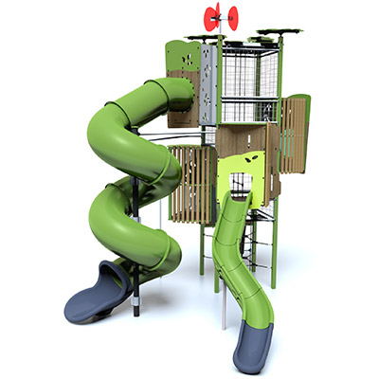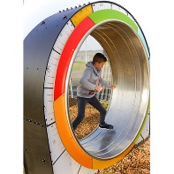

- A Cubicle with lockable door 2 X 2 m, including:
- A cloakroom corner => clothes racks, hangers
- Possibility to store documents & snacks: provide shelves
- Spacious fridge

2/ OPTION 2

- Maximum Visibility
- The stand should catch the eye from the hall entrances
- The stand must enable visitors to understand our activity immediately and pull them onto it
- For this we want 4 open sides – an island stand

- Reception
- Provide 2 reception areas, including one with bar area

- Discussion areas
- 3 areas to accommodate 4 people at the same time

- Virtual reality space
- With 2 helmets and 2 screens to view what visitors see in the helmet

- Large projects area
- Put forward great visuals of our project achievements with screens that show video and images

- Outdoor equipment which will be present on the stand:
- Play equipment: Roll Runner, Van, Kanopé timber-look J5604C

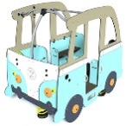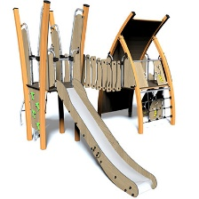

- A Cubicle with lockable door 2 X 2 m, including:
- A cloakroom corner => clothes racks, hangers
- Possibility to store documents & snacks: provide shelves
- Spacious fridge

